Amazon ECS (Elastic Container Service)
- Amazon ECS (Elastic Container Service) is a fully managed container orchestration service that simplifies the deployment, management, and scaling of containerized applications on AWS, allowing you to run and manage Docker containers without needing to manage the underlying infrastructure.
- We can run the containers on the Docker, then why to use ECS?
- Drawbacks for Docker
  - It doesn’t support Auto scaling
  - It doesn’t support Auto Healing
- Due to the above drawbacks, the application won’t be highly available
- So, Amazon camp up with an ECS service to address these issues
- We can address this with the help of Kubernetes as well.
- Here ECS is not using Kubernetes features like nodes, pods, etc., instead they have task definition, tasks, services, clusters, etc..,
- Kubernetes is an open source, whereas ECS is not an open source and it’s restricted to AWS only
- Kubernetes provides more flexibility
- Kubernetes provide more feature when compared to ECS like CRDs etc.,
- But ECS is a simple service whereas Kubernetes is complex architecture with many advanced features
- In real-time, EKS/Kubernetes is being used over ECS

Steps to setup the ECS
- Let’s create a ECR(Elastic Container Registry) repository first to store the docker images
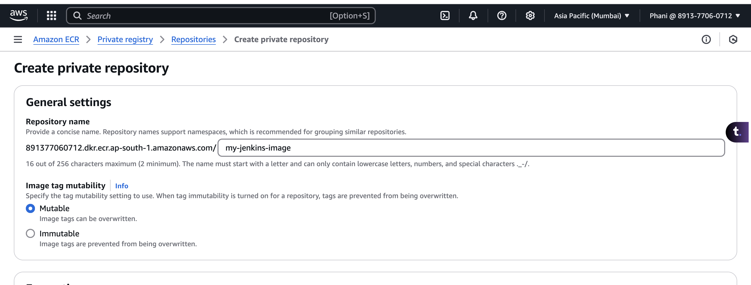
- With the help of push commands, push the docker image to the ECR
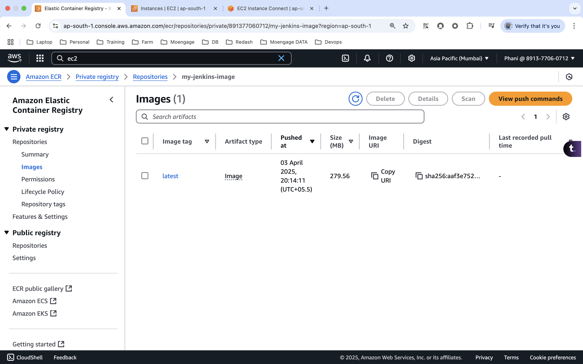

- On ECS, we need to create the cluster first. While creating the cluster, we have an option to choose the infrastructure.

  - Fargate – This is a serverless option where the entire server is maintained and configured by the AWS
  - EC2 instance – We need to configure and maintain the server
- We can also enable the monitoring and encryptions on the cluster
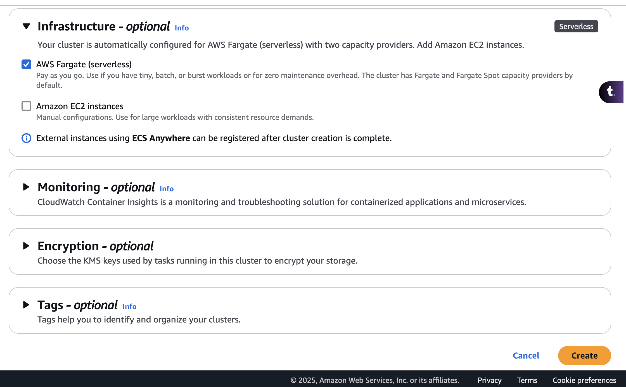
- Once the cluster is created, we need to create a task definition, which is nothing but a blueprint.
- Task Definitions define how your containers should run, including the Docker image to use, CPU and memory requirements, port mapping, networking, and more. It is like a blueprint for your containers.
- For Jenkins we need to map the 8080 and 50000 ports, and add the image URI which we have in ECR.
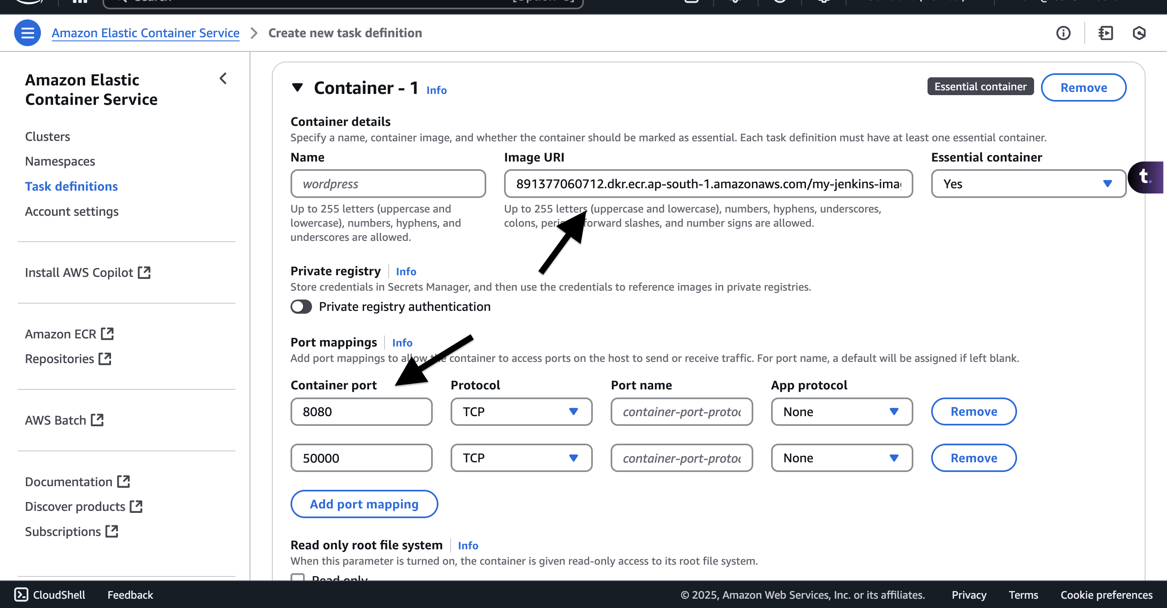
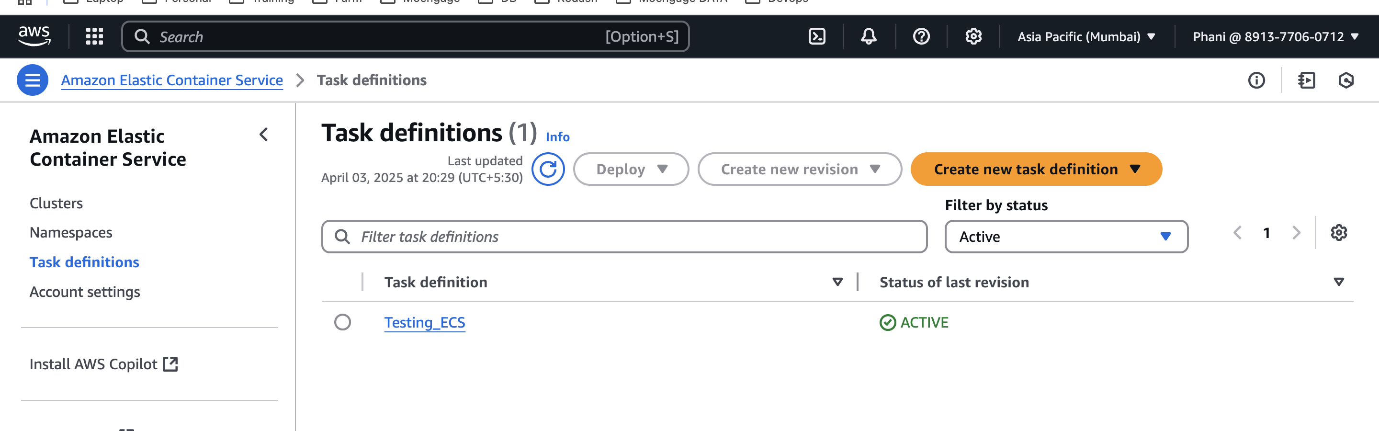
- Now let’s create a task, which will run the container with the help of task definition which we have created earlier.
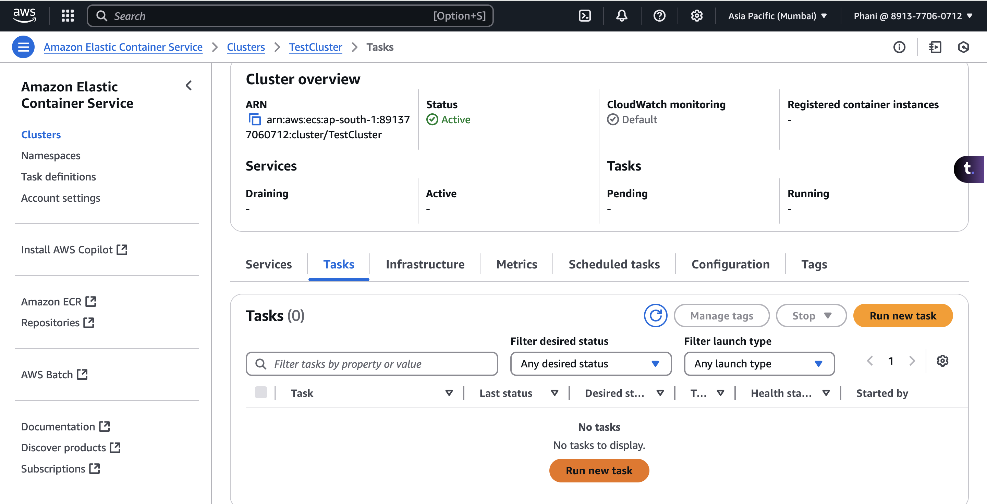
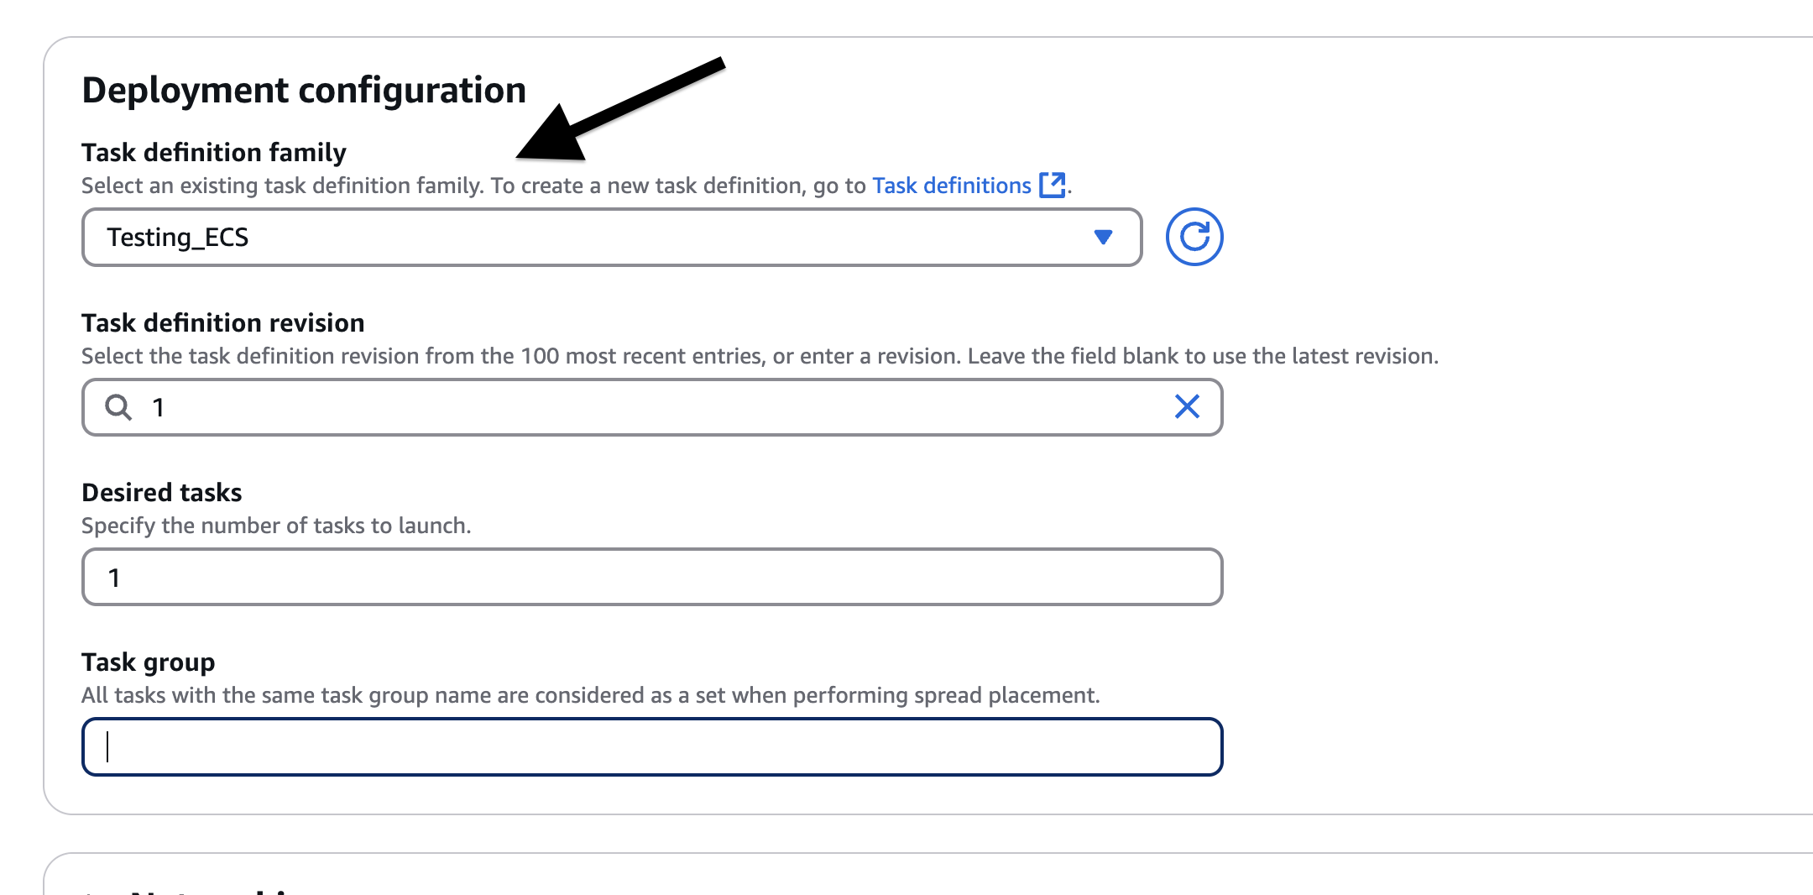
- Once the task is in running state, we can get the IP address under the network bindings using which we can access the application.
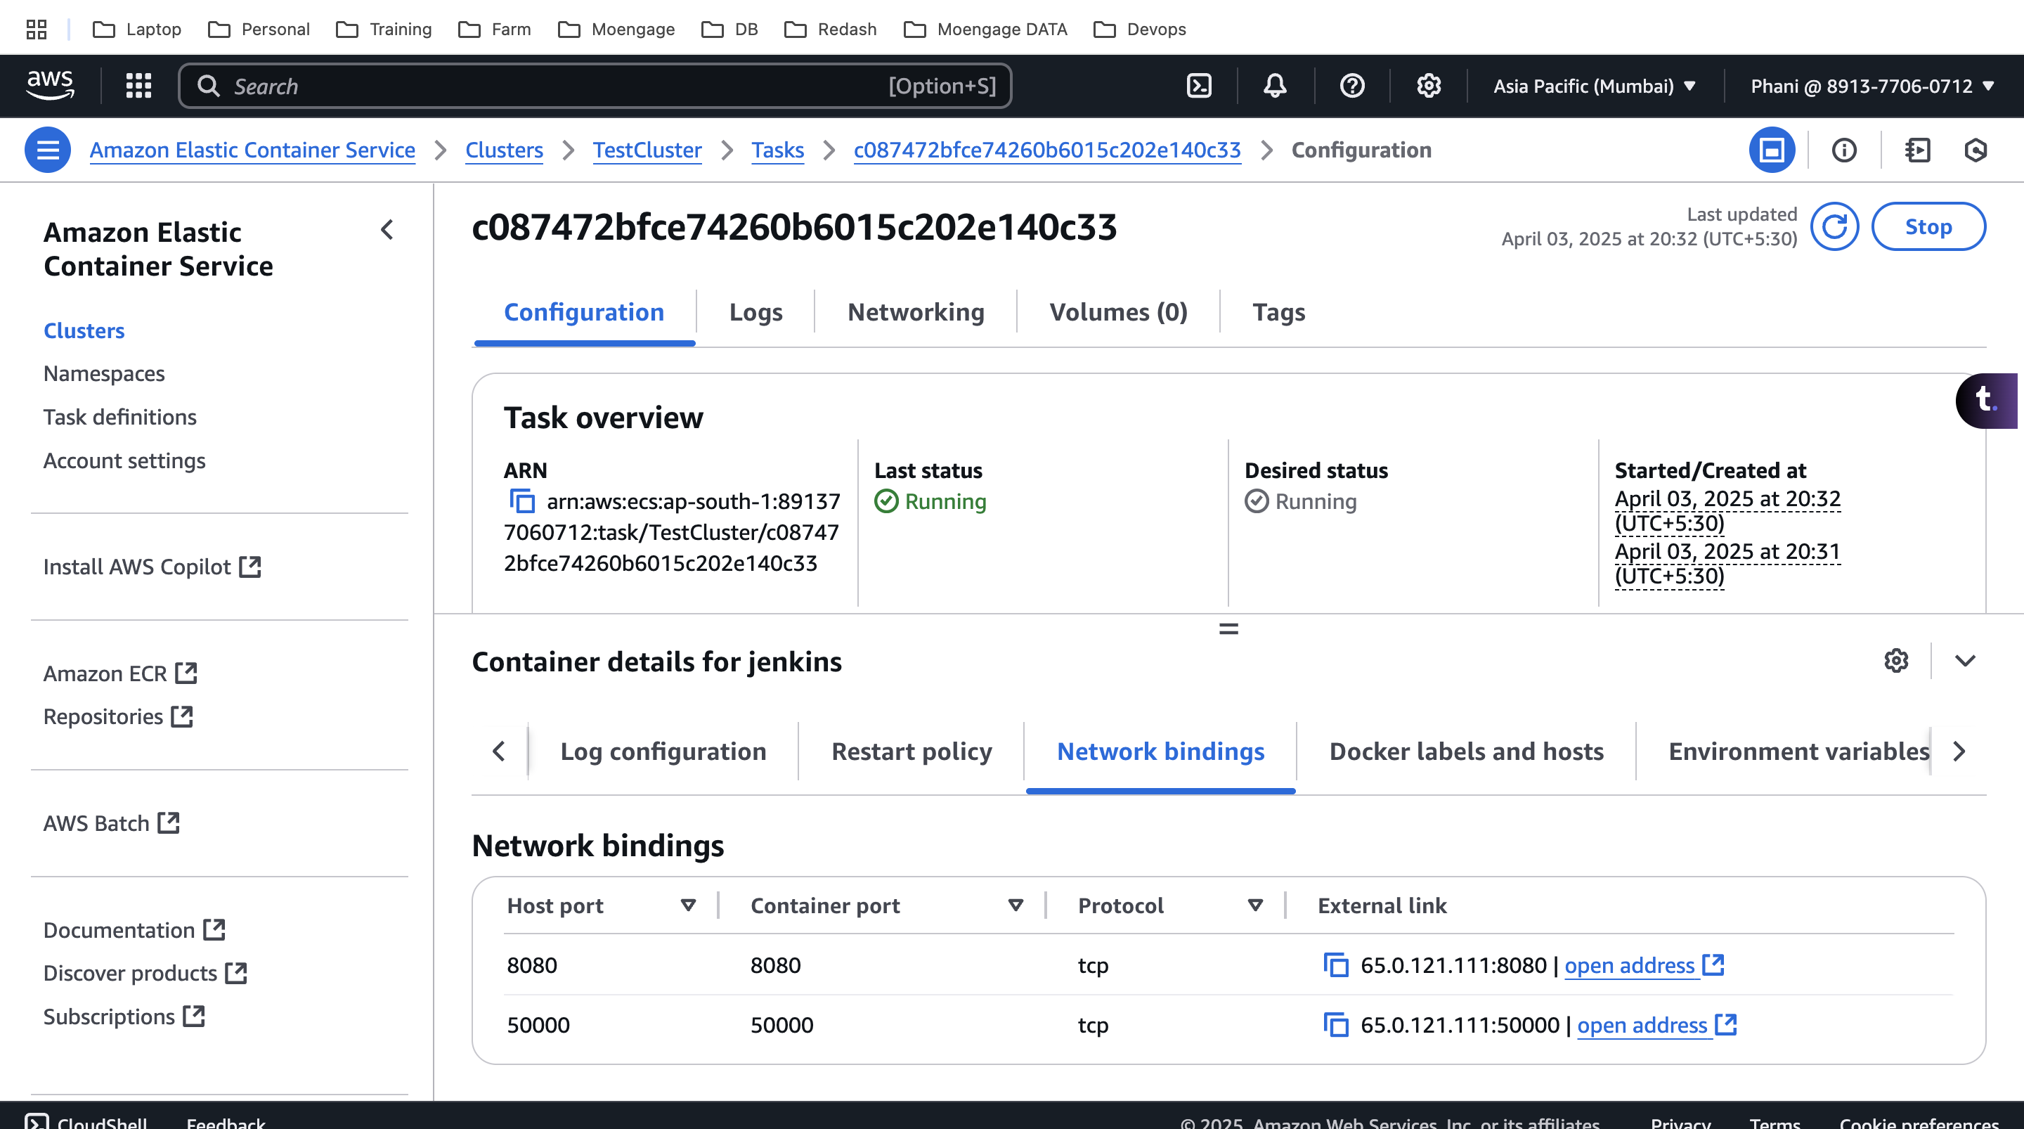
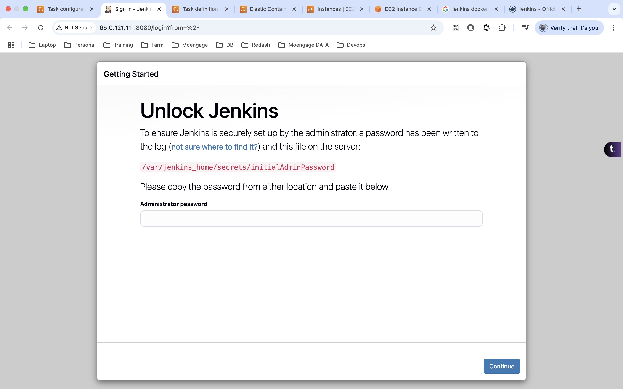
- We can create a service, which help you maintain a specified number of running tasks simultaneously, ensuring high availability and load balancing for your applications.
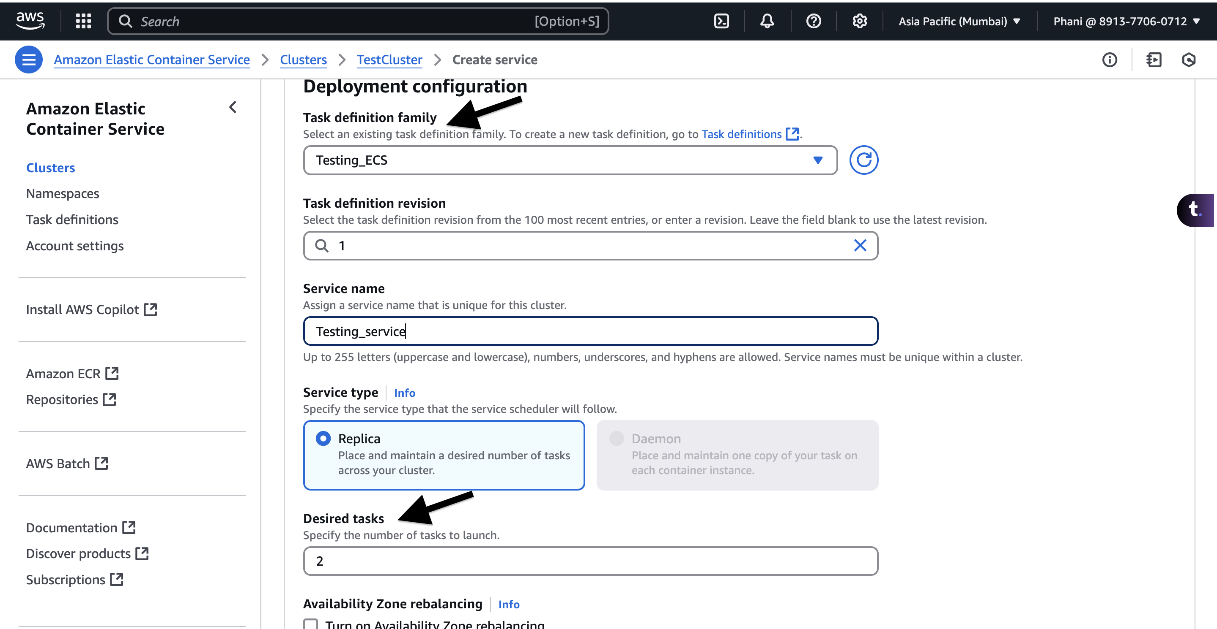
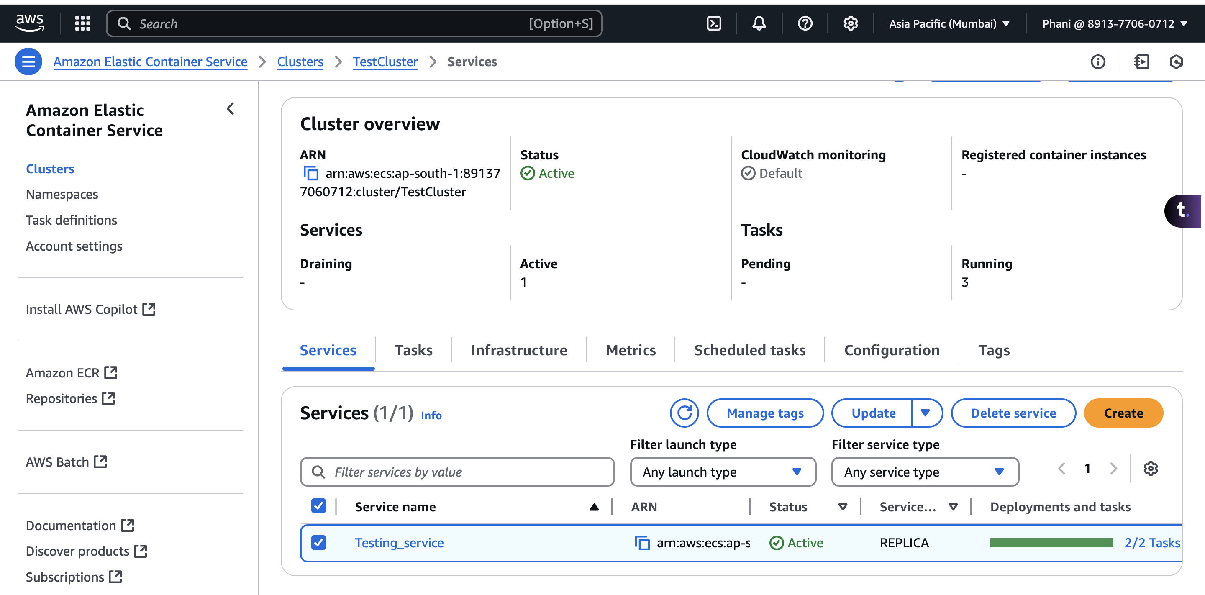
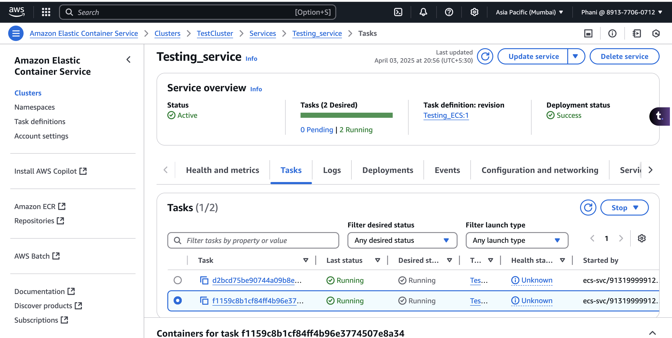
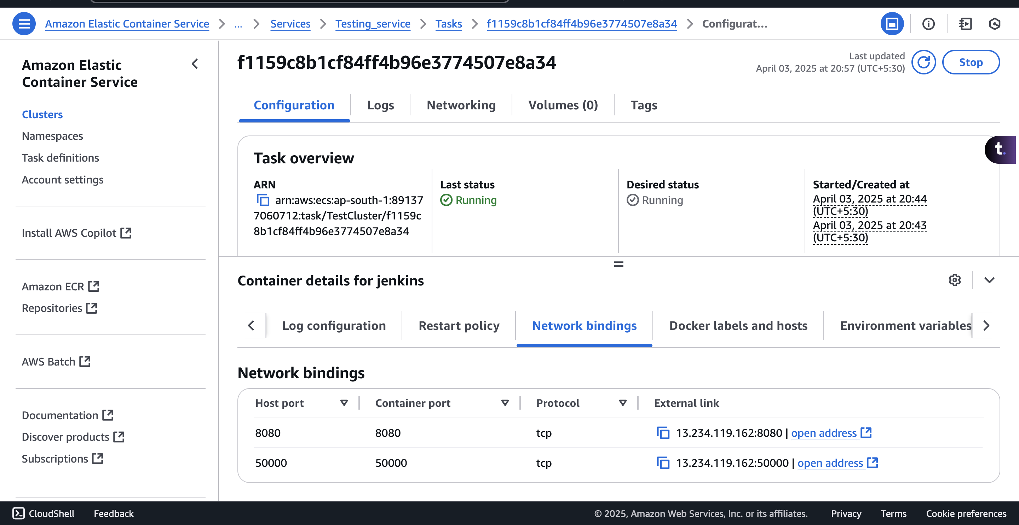
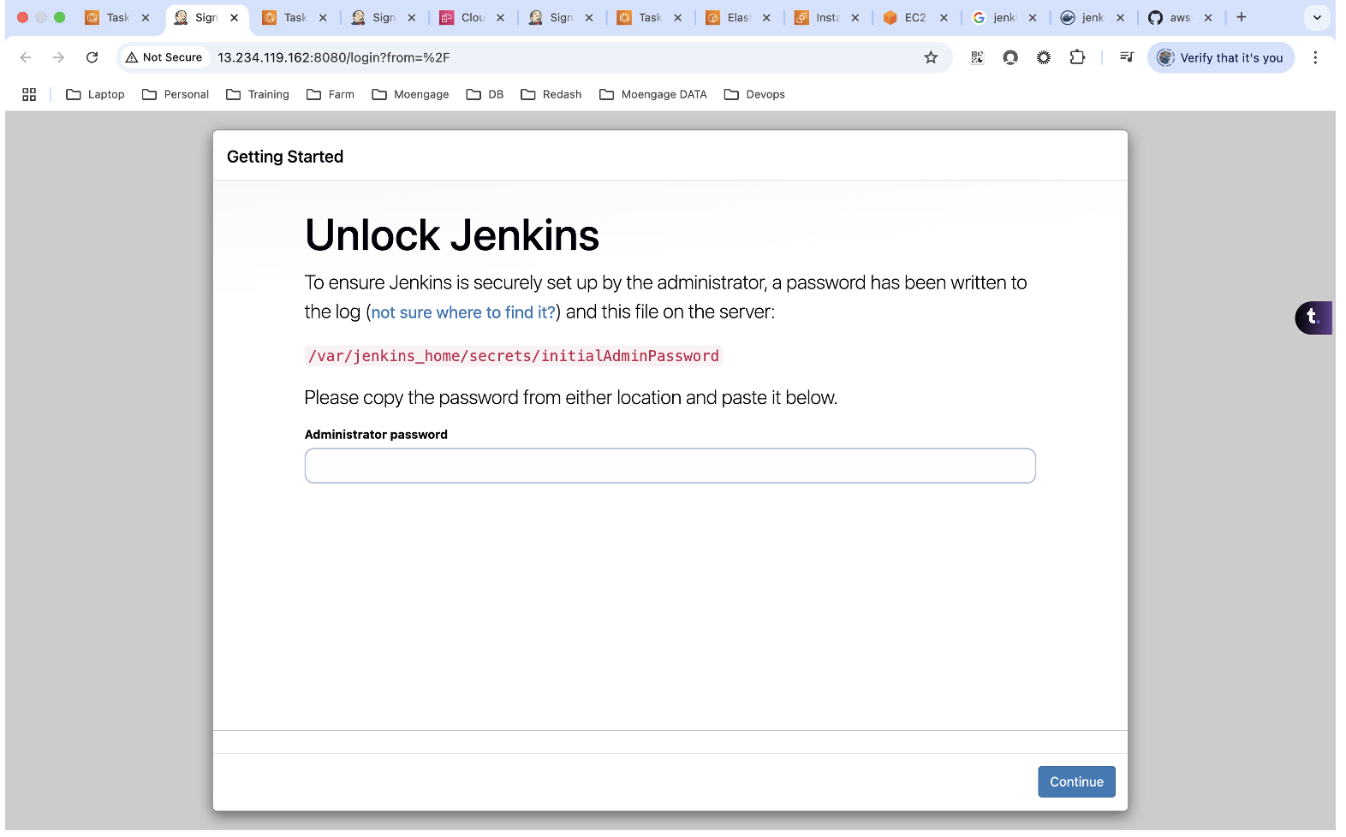
- We can setup and load balancer for this service to distribute the load across the containers.

